**Automatic Door Open Close**

Course: Microprocessor and Microcontroller Lab (CSE-316)

Program: B.Sc. in CSE

**Developed by:**

|  |  |  |
| --- | --- | --- |
| **ID** | **Intake** | **Name** |
| 19201103011 | 43 | Tushi Dash |
| 19201103016 | 43 | Partho Debnath |
| 19201103017 | 43 | Fayezur Rahman |
| 19201103021 | 43 | Sanjana Islam |
| 19201103022 | 43 | Md. Shohanur Rahman |
| 19201103032 | 43 | Jack Pritom Soren |
| 18193103019 | 42/1 | Md. Jamiul Haque Jamy |

**Supervised by:**

Fahima Khanam

Lecturer

Department of CSE

Date of Submission: March 23, 2022



**TABLE OF CONTENTS**

|  |  |
| --- | --- |
| Introduction | 02 |
| Principle behind the Project | 02 |
| Objectives | 02 |
| List of Equipment | 03 |
| Application of the Project | 06 |
| Design of the Project | 07 |
| Arduino Code | 07 |

**Introduction**

The purpose of this project is to automatically open the door by detecting body temperature. To a certain extent, guarantee the safety of the living environment. Automatic doors effectively contribute to energy saving and reduce annual heating and cooling costs.

Doors open only when activated and automatically close so to eliminate the doors being left open. They also prevent air-conditioning from escaping and outside air and dust from entering.

**Principle Behind the Project**

The principle of the project lies in the functioning of the PIR Sensor. A PIR or Passive Infra-red Sensor, as the name indicates, doesn’t emit infrared rays but only detects them.

All humans emit infrared radiations in the form of body heat. A PIR Sensor will capture the difference between the room temperature and body temperature in the form of change in infrared radiation.

This change in infrared pattern is converted to a voltage. The voltage from the Data Out of the PIR Sensor can be given to a microcontroller for further processing like controlling a motor etc.

**Objectives**

Automatic Door Opening System is a simple automated system, where the door is automatically opened up on detecting a person and automatically closes after some time.

Opening and closing of doors have been always a tedious and boring job, especially in places where a person is always required to open the door for visitors such as hotels, restaurant, shopping malls etc.

**List of Equipment**

* **Arduino Uno**

The Arduino Uno is an open-source microcontroller board based on the Microchip ATmega328P microcontroller and developed by Arduino.cc. The board is equipped with sets of digital and analog input/output pins that may be interfaced to various expansion boards and other circuits.

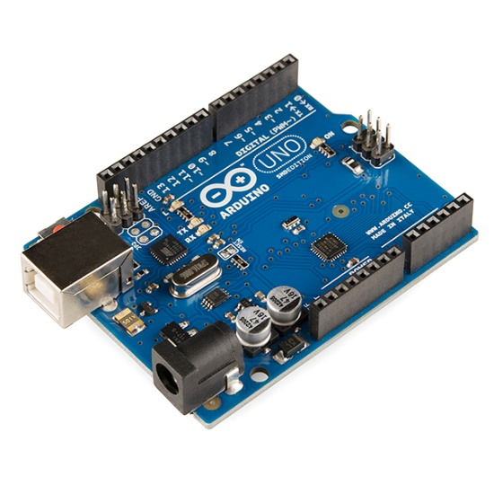

* **Passive Infrared Sensor**

A passive infrared sensor (PIR sensor) is an electronic sensor that measures infrared (IR) light radiating from objects in its field of view.

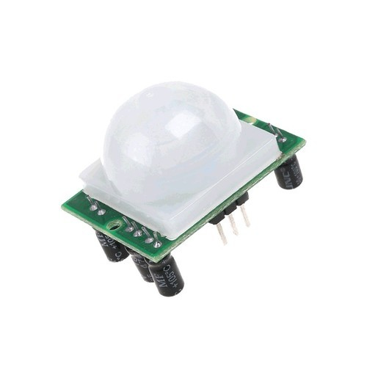

* **Motor**

It is a rotating device (device which rotates or move round and round) It converts electrical energy into mechanical energy. They are used in Electric fans, Refrigerators, Washing Machines, Mixers, etc.

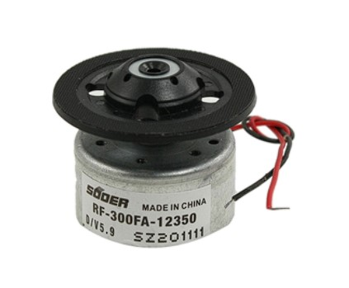

* **L293N Motor Driver**

This motor driver is perfect for robotics and mechatronics projects and perfect for controlling motors from microcontrollers, switches, relays, etc.

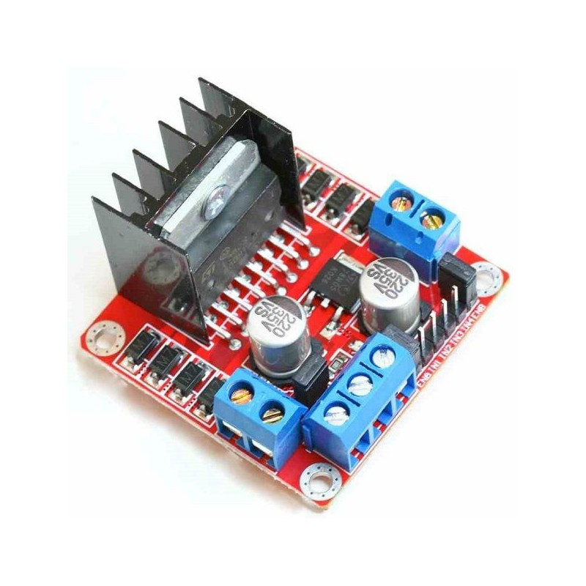

* **Red LED**



* **Connecting Wires**

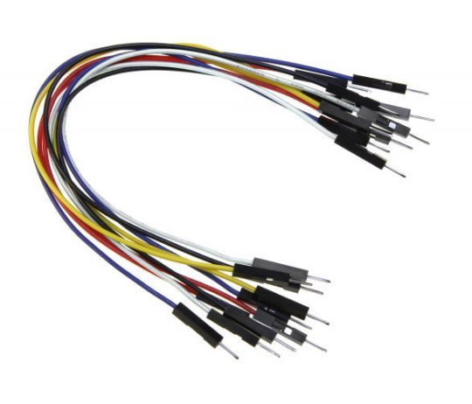

* **9v Battery**

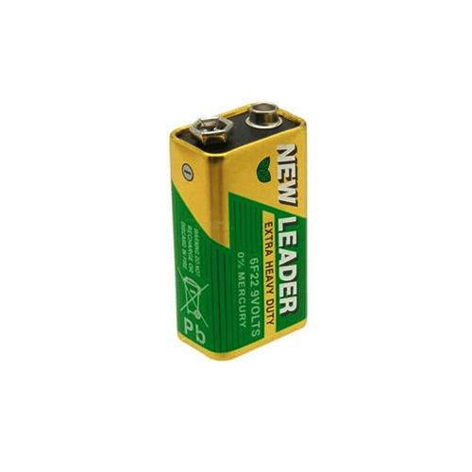

* **Battery Connector**

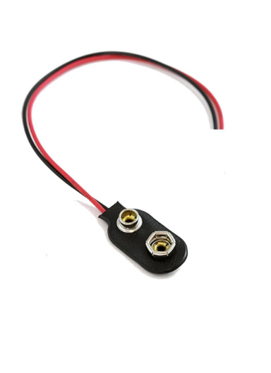

**Application of the Project**

* Automatic Door Opening System can be implemented where the door is automatically opened and closed without any manual control.
* Since the door is opened only when a person is detected and remains close all other times, it can save a lot of energy in the form air conditioning.
* An automatic door system with sliding doors can be useful for aged and disabled.
* Can be implemented with additional features like face detection to track the trajectory in security applications.

**Design of the Project**

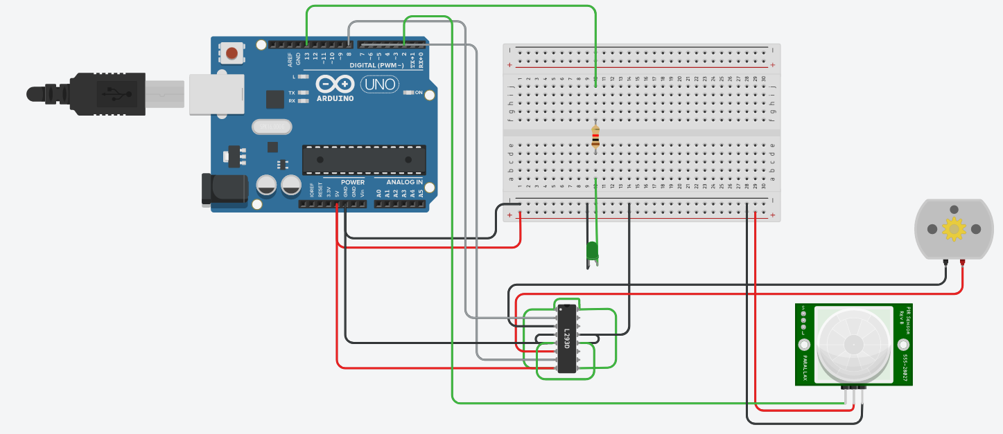

**Arduino Code**

int led = 13;

int pirsen = 2;

int in1 = 7;

int in2 = 8;

int pirState = 0;

void setup() {

pinMode(in1, OUTPUT);

pinMode(in2, OUTPUT);

pinMode(led, OUTPUT);

pinMode(pirsen, INPUT);

Serial.begin(9600);

}

void loop() {

if (digitalRead(pirsen) == HIGH) {

Serial.println("Motion Detected!");

if (pirState == 0) {

digitalWrite(led, HIGH);

Serial.println("......................Motor Run {Door Opening start}...............");

digitalWrite(in1, HIGH); // motor

digitalWrite(in2, LOW); // motor

pirState = 1;

delay(500);

Serial.println("......................Motor Run {Door is Open}...............");

}

Serial.println("......................{Door is Open}...............");

}

else{

Serial.println("Motion Ended!");

if(pirState == 1){

delay(5000);

Serial.println("......................Motor Run {Door Closing start}...............");

digitalWrite(in1, LOW); // motor

digitalWrite(in2, HIGH); // motor

pirState = 0;

delay(500);

Serial.println("......................Motor Run {Door is Close}...............");

digitalWrite(led, LOW);

}

Serial.println("......................{Door is Close}...............");

}

Serial.println("......................Motor Stop...............");

digitalWrite(in1, LOW); // motor

digitalWrite(in2, LOW); // motor

}